**Salads  
Grilled Chicken Breast Salad $7.95**

Tender marinated chicken breast strips on a bed of crisp mixed greens, lettuce, tomato, cucumber, red onion, black olives, bell pepper

**Teriyaki Chicken Salad** **$7.95**

Tender marinated Teriyaki chicken breast strips on a bed of crisp mixed greens, lettuce, tomato, cucumber, red onion, black olives, bell pepper

**Greek Salad**  **$7.95**

Fresh mixed greens, lettuce, tomato, cucumber, red onion, black olives, bell pepper, crumbled feta cheese tossed with our own Greek dressing.

**Antipasta Salad** $**7.95**

Sliced Salami, Pepperoni, Giardenera, Provolone Cheese and black olives atop fresh mixed greens, lettuce, served with Italian dressing.

**Caesar Classic** **$7.00**

Romaine lettuce, croutons, fresh grated parmesan cheese, Caesar dressing

**Small Garden Salad** **$3.95**

An assortment of fresh lettuce, carrot, tomato, cucumber, red cabbage  
  
**Soup of the Day**

Delicious house made Clam Chowder or Soup of the day

Cup $3.95  
Bowl $4.95  
  
**Small bowl of House Made Chili $2.95**

**Starters  
Cheese & Bacon Potato Skins $5.95**

Topped with bacon and melted cheddar served with sour cream

**Onion Rings $6.95**

Deep fried to crispy, golden brown perfection

**Jumbo Wings**  
Buffalo, Barbeque or Sweet & Sour  
6 for $5.95 10 for 8.95

Served with Ranch, Bleu Cheese or Honey Mustard Dressing

**Deep Fried Mushrooms $5.95**

Topped with Parmesan cheese. Served with ranch dip

**Fried Zucchini $5.95**

A basket of breaded zucchini, deep fried to Golden brown.  
Served with ranch dip

**Spicy Hot Boneless Chicken Strips**

6 for $5.95 10 for $6.95  
  
Chips and Salsa $2.95  
Featuring our house made salsa

**Special Mini Sampler Plate $9.95**

5-Chicken Wings (hot or bar-be-que)

4-Onion rings, 4-zucchini, 4-mozzarella sticks

**Jalapeno Poppers $7.95**

Spicy Jalapeno peppers and cheddar cheese, deep fried in  
a light batter served with ranch dressing

**Cheese Quesadilla $6.25**

Melted jack and cheddar cheese with chives

on a crisp golden brown flour tortilla. Served with fresh salsa

**Grilled Chicken Quesadilla $7.95**

Melted jack and cheddar cheese with marinated chicken breast  
on a crisp golden brown flour tortilla, Served with fresh salsa

**Mozzarella Sticks $6.95**

Italian style breaded mozzarella sticks

Served with our own marinara sauce

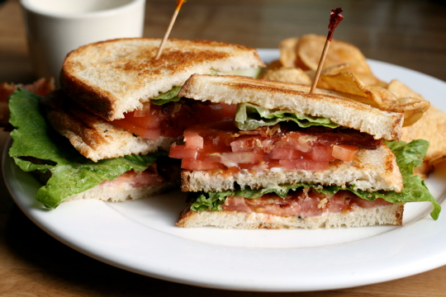

**B.L.T.** $4.95

**B.L.T. with Avocado** $6.95

Grilled Cheese on Choice of Bread $3.95

Grilled Cheese & Ham on Choice of Bread $4.95

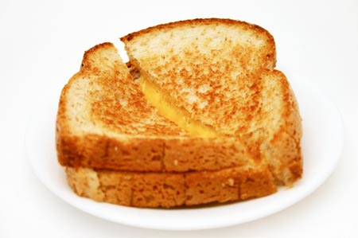



**1/2 Chicken Barbeque or Fried**Includes 2 sides: Baked Potato, French Fries,  
Baked Beans, Cole Slaw or Potato Salad



**$6.95**

**Steak**Includes 2 sides: Baked Potato, French Fries,  
Baked Beans, Cole Slaw or Potato Salad  **8 oz. Boneless Rib Eye Steak $13.95**With sautéed mushrooms

**8 oz. Boneless Rib Eye Steak $12.95**

**8 oz Top Sirloin Steak $8.95**

**20 oz Top Round Steak $9.95**

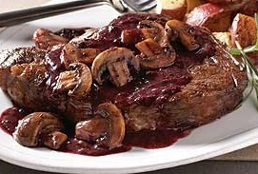

**Barbeque Pork Ribs  
with our special Hickory Smoked sauce**Includes 2 sides: Baked Potato, French Fries,  
Baked Beans, Cole Slaw or Potato Salad  
   
**Half Rack $13.95**

**Full Rack $21.95**

**A Taste of Italy**

**Fettuccine Alfredo**  $12.95  
Includes choice of soup or salad

Fettuccine served in a traditional Alfredo sauce.  
Add chicken $2.00  
  
**Fettuccine Ai Funghi**  $14.95  
Includes choice of soup or salad

Fettuccine with mushrooms, garlic, parsley and extra virgin olive oil4

**Spaghetti & Marinara Sauce**  $6.95  
Includes choice of soup or salad

Mushrooms and house made marinara sauce

Add Meat Sauce $10.95  
  
**Spaghetti & Meat Balls** $14.95Includes choice of soup or salad

Hand Made ‘Melt in your Mouth’ Meat Balls on Spaghetti and  
our meat and mushroom sauce  
  
**Cheese Lasagna** $13.95  
Includes choice of soup or salad

Mozzarella cheese, Parmesan cheese, ricotta, marinara sauce

**Meat Lasagna** $15.95  
Includes choice of soup or salad

Ground beef, Mozzarella cheese, Parmesan cheese, Ricotta, marinara sauce

**12" Calzones $9.95  
Any 3 Items**

Each additional topping $1.25

Toppings: Pepperoni, sausage, bacon, Canadian bacon, meatballs, salami, hamburger, grilled chicken, ham, anchovies, mushrooms, tomatoes, bell peppers, red onion, white onion, green onion, olives, basil, pineapple, feta cheese

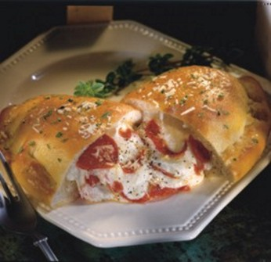

New York Style Pizza  
Toppings: Pepperoni, sausage, bacon, Canadian bacon, meatballs, salami, hamburger, grilled chicken,

ham, anchovies, mushrooms, tomatoes, bell peppers, red onion, white onion, green onion, olives, basil, pineapple, feta cheese

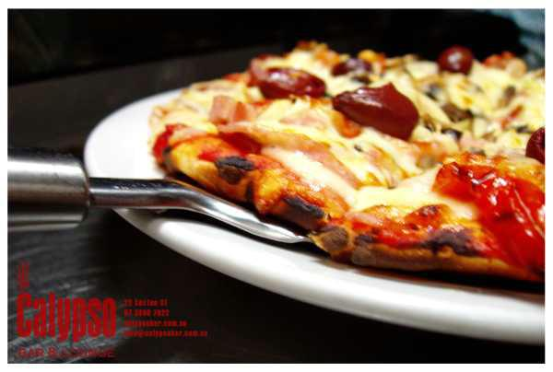

*12 inch Cheese Pizza $5.00 or Cheese & 1 Topping $6.00*  
Each Additional Topping $1.00

**Cheese Pizza** (or any one topping) $11.99 $14.99

**Cheese & Pepperoni** (or any one topping) $13.49 $16.95

**Cheese, Sausage & Pepperoni** (or any two toppings) $14.99 $18.49

**“The Vegetarian”** Cheese, Mushrooms, Bell Pepper and Onion  
 (or any Three Toppings) $16.49 $20.49

**“The Works”** Pepperoni, Bell Pepper and Onion  
 (or any Three Toppings) $16.49 $20.49

**“The Mona Lisa”** Ham, Pineapple, Tomatoes, Onions  
 (or any Four Toppings) $17.99 $21.99

**“The Pizza Supreme”** Pepperoni, Bacon, Tomatoes, Ground Beef,  
 Black Olives (or any Five Toppings) $19.49 $23.99

**“The Godfather”** Pepperoni, Sausage, Bell Pepper, Mushrooms,  
 Black Olives, Onions, (or any Six Toppings) $20.99 $25.49

**“The Graveyard”** We put a little bit of everything on this one! $22.49 $27.49  
 *Each additional topping* $ 1.50 $ 1.75

16 inch 20 inch

**12 inch Italian Gourmet Pizza**

**“Pizza Margherit “** Fresh tomatoes, fresh basil, garlic & mozzarella $9.95  
**“BBQ Chicken Pizza”** Grilled chicken, bacon, red onion, BBQ sauce (no pizza sauce) and cheese $10.95

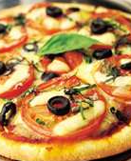

**Add House Made Chili on Top $1.00**

**Small Large  
 French Fries $1.00 $1.75**

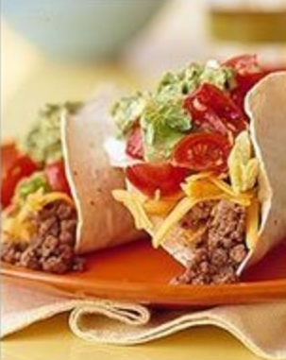

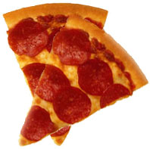

Coffee $1.75  
Tea $1.75  
Juice $1.75

**Drinks**

Pepsi, Diet Pepsi, Mountain Dew, Sprite,  
Dr. Pepper, Root Beer, Ice Tea   
   
24 oz $1.75

**Pepperoni Pizza Slice $1.75  
2 Mini Burgers $1.00  
Bean & Cheese Burrito $1.00  
Hot Dog Regular 2 for $1.00  
Hebrew National Jumbo $1.50  
Polish Sausage $1.50  
Soft Taco $1.00  
Crispy Taco $1.00**

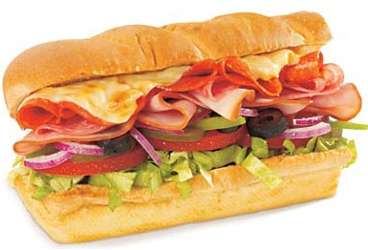

**Sub Sandwiches  
Foot Long $5.00 6 inch $3.95  
Choose your meat & cheese  
Customize your sandwich at our  
*Custom Creations Bar!***

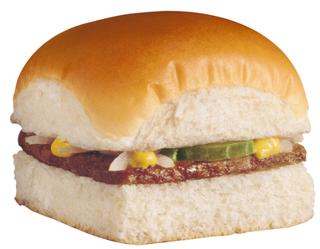



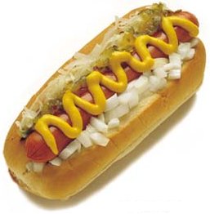

**Value Menu**

[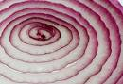](http://images.google.com/imgres?imgurl=http://farm2.static.flickr.com/1321/993311118_69e50e8efe.jpg&imgrefurl=http://www.flickr.com/photos/71502646@N00/993311118/&h=343&w=500&sz=128&hl=en&start=12&usg=__gs9lyHIgQTWqWyTzoxJaXsxEsug=&tbnid=AAMTqS6abUNRcM:&tbnh=89&tbnw=130&prev=/images?q=red+onion&gbv=2&hl=en)

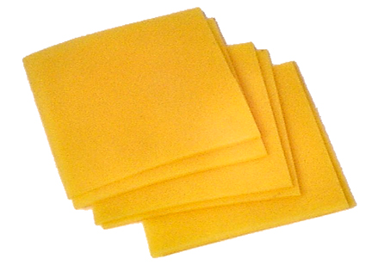

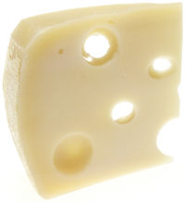

*Served on a Texas size sesame bun*

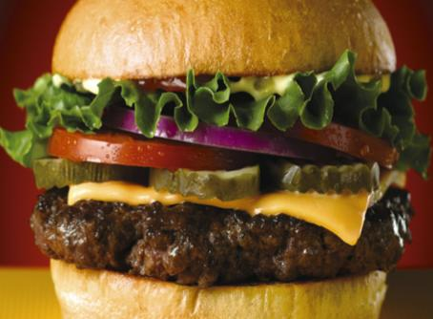

***Choose your Meat!***

***Get Creative! Add cheese & Premium toppings. $1*** *Additional Charge for each*

***Dress Things Up at our Custom Creations Bar! No Extra Charge***

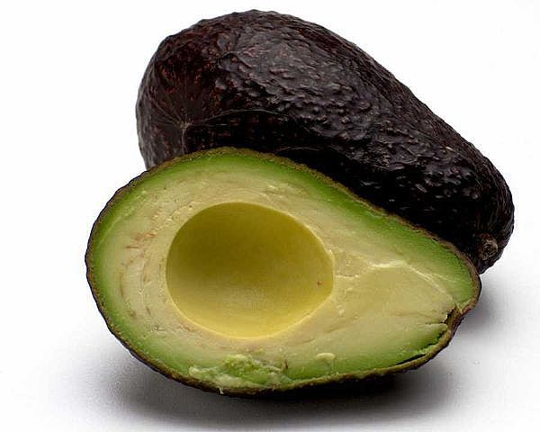

Grilled Pineapple  
Sliced Avocado  
2 Strips of Bacon  
Sauer Kraut  
Mushrooms

American Cheese  
Cheddar Cheese   
Swiss Cheese  
Ortega Chiles  
House Made Chili

Custom Burger & Chicken Creations

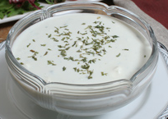

1/4 pound Ground Steak Burger $3.95  
1/2 pound Ground Steak Burger $5.95  
1/4 pound Veggie Burger $3.95  
1/2 pound Veggie Burger $5.95  
1/2 pound Grilled Chicken Breast $5.95

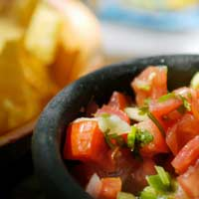

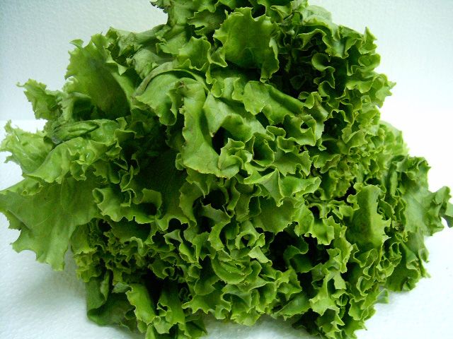

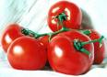

Tomato  
Pickle  
Lettuce  
Onion  
Sliced Cucumber  
Jalapeno  
Salsa

Thousand Island  
Italian Dressing  
Mayonnaise  
Ranch Dressing  
Barbeque Sauce  
Bleu Cheese Dressing  
Katsup & Mustard

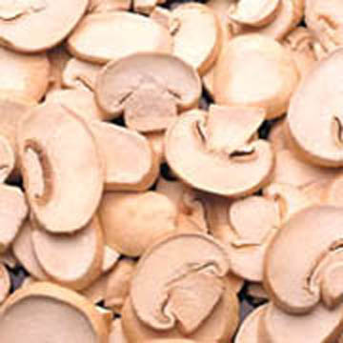

***Cocktails***

**Kahlua & Cream $6**  
Kahlua, Cream  
**Alabama Slammer $7**  
Southern Comfort, Amaretto, Sloe gin, Lemon juice  
**3 Wise Men $7**  
Jack Daniels, Johnnie Walker, Jim Beam

**Martini $6**  
Gin, Dry Vermouth, Olive  
**Chocolate Martini $7**  
Creme de Cacao, Vodka  
**Appletini $7**Vodka, Apple schnapps, Apple juice

**Carbomb $7**  
Guinness stout, Bailey's Irish cream, Whiskey  
**A Piece of Ass $7**  
Amaretto, Southern Comfort, Ice, Sour mix  
**A Southern Screw $7**  
Vodka, Southern Comfort, Orange juice, Ice  
**Buttery Nipple $7**  
Butterscotch schnapps, Bailey's irish cream

**Sex on the Beach $7**  
Vodka, Midori melon liqueur, raspberry liqueur, Pineapple juice  
**Screaming Orgasm $7**  
Vodka, Bailey's irish cream, Kahlua  
**Adios Motherf*****! $7**  
Vodka, Rum, Tequila, Gin, Blue Curacao, Sour mix, 7-Up  
**Mind Eraser $7**  
Ice, Kahlua, Vodka, Sprite  
**Rusty Nail $7**  
Scotch, Drambuie, Lemon peel  
**Mojito** **$7**  
Light rum, Lime, Sugar, Soda water  
**Mai Tai $7**  
Light rum, Orgeat syrup, Triple sec, Sweet and sour, Cherry

**Cosmopolitan $7**  
Vodka, Triple sec, Sweetened lime juice,  
Cranberry juice, Lime

**Tequila Sunrise $7**  
Tequila, Orange juice, Grenadine

**Screw Driver $6**  
Vodka, Orange juice  
**Kamakazie $6**  
Vodka, Triple sec, Sweetened lime juice  
**Day at the Beach $7**  
Coconut rum, Amaretto, Orange juice, Grenadine  
**Gilligan's Island $7**  
Vodka, Peach schnapps, Orange juice, Cranberry juice  
**B-52 $7**  
Kahlua, Amaretto, Bailey's irish cream  
**Amaretto Sour $6**  
Amaretto, Sour mix  
**Mudslide $7**  
Vodka, Kahlua, Bailey's irish cream  
**Bahama Mama $7**  
Coffee liqueur, Dark rum, Coconut liqueur, 151 proof rum,  
Lemon, Pineapple juice  
**Stawberry Daquiri $6**  
Strawberries, Light rum, Lime  
**Long Island Iced Tea $7**  
Vodka, Tequila, Rum, Gin, Triple sec, Sour mix, Pepsi  
**Pina Colada $6**  
Light rum, Coconut milk, Pineapple  
**Margarita $6**  
Tequila, Triple sec, Lime juice, Salt  
**Black Russian $7**  
Coffee liqueur, Vodka  
**White Russian $7**  
Vodka, Coffee liqueur, Light cream

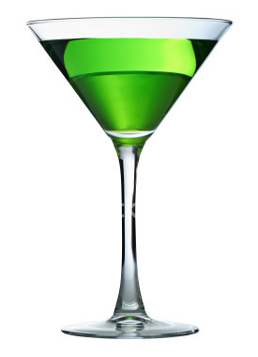

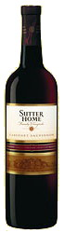

**Sparkling Wines**  
**Brut Grand Imperial $18.95  
Brut Grand Imperial by the glass $7.95  
Brut Piper Sonoma $45.00  
Brut Prestige Mumm Napa $45.00**

Camelot Chardonnay 2006 $25.00  
  
Jacob's Creek $45.00  
Chardonnay Reserve 2007  
  
St. Francis Red Zinfandel $45.00  
"Old Vines" 2005

**California Wines**

By the Bottle

Sutter Home White Zinfandel $4.95 $14.95  
Medium body with strawberry and watermelon  
flavors with a delightful refreshing finish  
Sutter Home Chardonnay $4.95 $14.95  
Medium body with pear and butterscotch flavors  
and a delicate touch of oak and clean crisp finish  
Sutter Home Merlot $4.95 $14.95  
Medium body with cherry and plum flavors with  
a bright clean finish  
Sutter Home Cabernet Sauvignon $4.95 $14.95  
Medium body with berry and black cherry flavors  
with soft tannins and a rich finish

By the Glass

